**CRICKET CLUB MANAGEMENT SYSTEM**

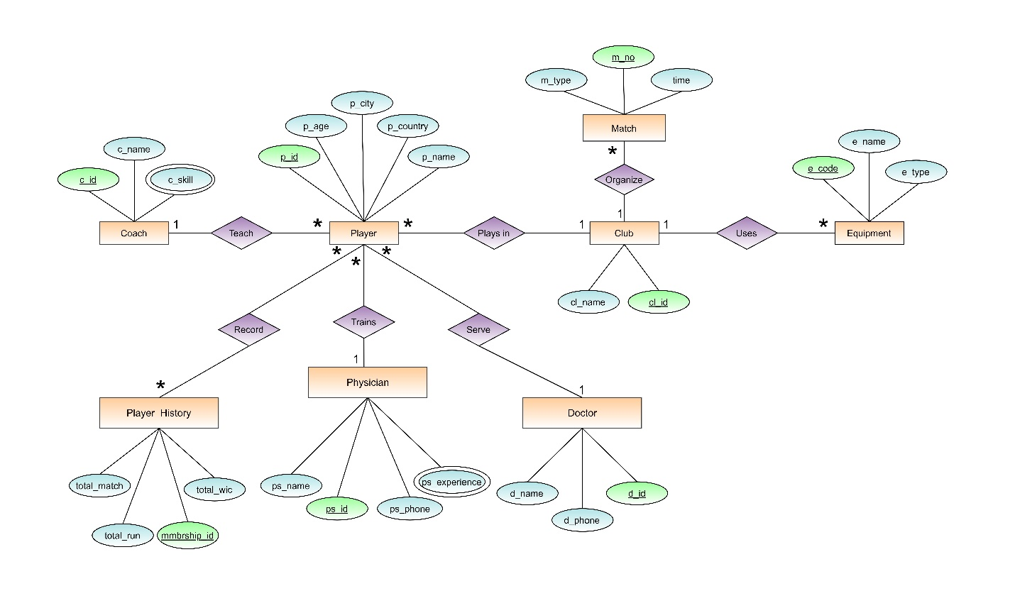

**Teach-(p_id,p_age,p_city,p_country,p_name,c_id,c_name,c_skill)**

**1NF: c_skill is multivalued attribute**

**2NF: p_id,p_age,p_city,p_country,p_name**

**c_id,c_name,c_skill**

**3NF: p_id,p_age, p_name**

**a_id,p_city,p_country**

**c_id,c_name,c_skill**

**Final list from Teach-**

1. **p_id,p_age,p_name,a_id,c_id**
2. **a_id,p_city,p_country**
3. **c_id,c_name**
4. **c_id,c_skill -> composite pk**

**Record- (p_id,p_age,p_city,p_country,p_name,mmbrship_id,total_match,total_run,total_wic)**

**1NF: No multivalued attribute**

**2NF: p_id,p_age,p_city,p_country,p_name**

**a_id,p_city,p_country**

**mmbrship_id,total_match,total_run, total_wic**

**3NF: p_id,p_age, p_name**

**a_id,p_city,p_country**

**mmbrship_id,total_match,total_run, total_wic**

**Final list for Record-**

1. **p_id,p_age,p_name, a_id**
2. **a_id,p_city,p_country**
3. **mmbrship_id,total_match,total_run, total_wic**
4. **n_id, p_id, mmbership_id**

**Trains-(p_id,p_age,p_city,p_country,p_name, ps_id,ps_name,ps_phone,ps_experience)**

**1NF: ps_experience is multivalued attribute**

**2NF: p_id,p_age,p_city,p_country,p_name**

**ps_id,ps_name,ps_phone,ps_experience**

**3NF: p_id,p_age, p_name**

**a_id,p_city,p_country**

**ps_id,ps_name,ps_phone,ps_experience**

**Final list for Trains-**

1. **p_id,p_age,p_name, a_id, ps_id**
2. **a_id,p_city,p_country**
3. **ps_id,ps_name,ps_phone,**
4. **ps_id,ps_experience -> composite pk**

**Serve-(p_id,p_age,p_city,p_country,p_name, d_id,d_name,ps_phone_no)**

**1NF: No multivalued attribute**

**2NF: p_id,p_age,p_city,p_country,p_name**

**d_id,d_name,ps_phone_no**

**3NF: p_id,p_age,p_name**

**a_id,p_city,p_country**

**d_id,d_name,ps_phone_no**

**Final list for Serve-**

1. **p_id,p_age, p_name, a_id, d_id**
2. **a_id,p_city,p_country**
3. **d_id,d_name,d_phone**

**Plays in--(p_id,p_age,p_city,p_country,p_name, cl_id,cl_name)**

**1NF: No multivalued attribute**

**2NF: p_id,p_age,p_city,p_country,p_name**

**cl_id,cl_name**

**3NF: p_id,p_age,p_name**

**a_id,p_city,p_country**

**cl_id,cl_name**

**Final list for Serve-**

1. **p_id,p_age, p_name, a_id, cl_id**
2. **a_id,p_city,p_country**
3. **cl_id,cl_name**

**Organize-(m_no,m_type,time,cl_id,cl_name)**

**1NF: No multivalued attribute**

**2NF: m_no,m_type,time**

**cl_id,cl_name**

**3NF: m_no,m_type,time**

**cl_id,cl_name**

**Final list for Organize-**

1. **m_no,m_type,time,cl_id**
2. **cl_id,cl_name**

**Uses-(e_code,e_name,e_type,cl_id,cl_name)**

**1NF: No multivalued attribute**

**2NF: e_code,e_name,e_type**

**cl_id,cl_name**

**3NF: e_code,e_name,e_type**

**cl_id,cl_name**

**Final list for Uses-**

1. **e_code,e_name,e_type,cl_id**
2. **cl_id,cl_name**

**Final list from normalization**

1. **p_id,p_age,p_name,a_id,c_id -> player**
2. **a_id,p_city,p_country -> location**
3. **c_id,c_name -> Coach**
4. **c_id,c_skill -> composite pk -> Qualification**
5. **mmbrship_id,total_match,total_run, total_wic -> Player_Details**
6. **n_id, p_id, mmbership_id -> Player_Identity**
7. **p_code,p_age,p_name, a_id, ps_id -> Trainer**
8. **ps_id,ps_name,ps_phone -> Physician**
9. **ps_id,ps_experience -> composite pk -> p_quality**
10. **p_id,p_age, p_name, a_id, d_id -> Player_Service**
11. **d_id,d_name,d_phone -> Doctor**
12. **p_id,p_age, p_name, a_id, cl_id -> Play**
13. **cl_id,cl_name -> Club**
14. **m_no,m_type,time,cl_id -> Match**
15. **e_no,e_name,e_type,cl_id -> Equipment**